
CLIENT: Lifefy
PROJECT: Video 60’ 30’ 15’
DATE UPDATED:
VERSION: 3
CREATIVE: Gloria/ Joa

1:00’ VO | VISUAL
- Let’s talk about how Lifefy is changing life insurance. | INTRO GFX
2. It all starts when you meet the one.  3. You get a puppy,  4. And buy a house.  Things start getting real. | 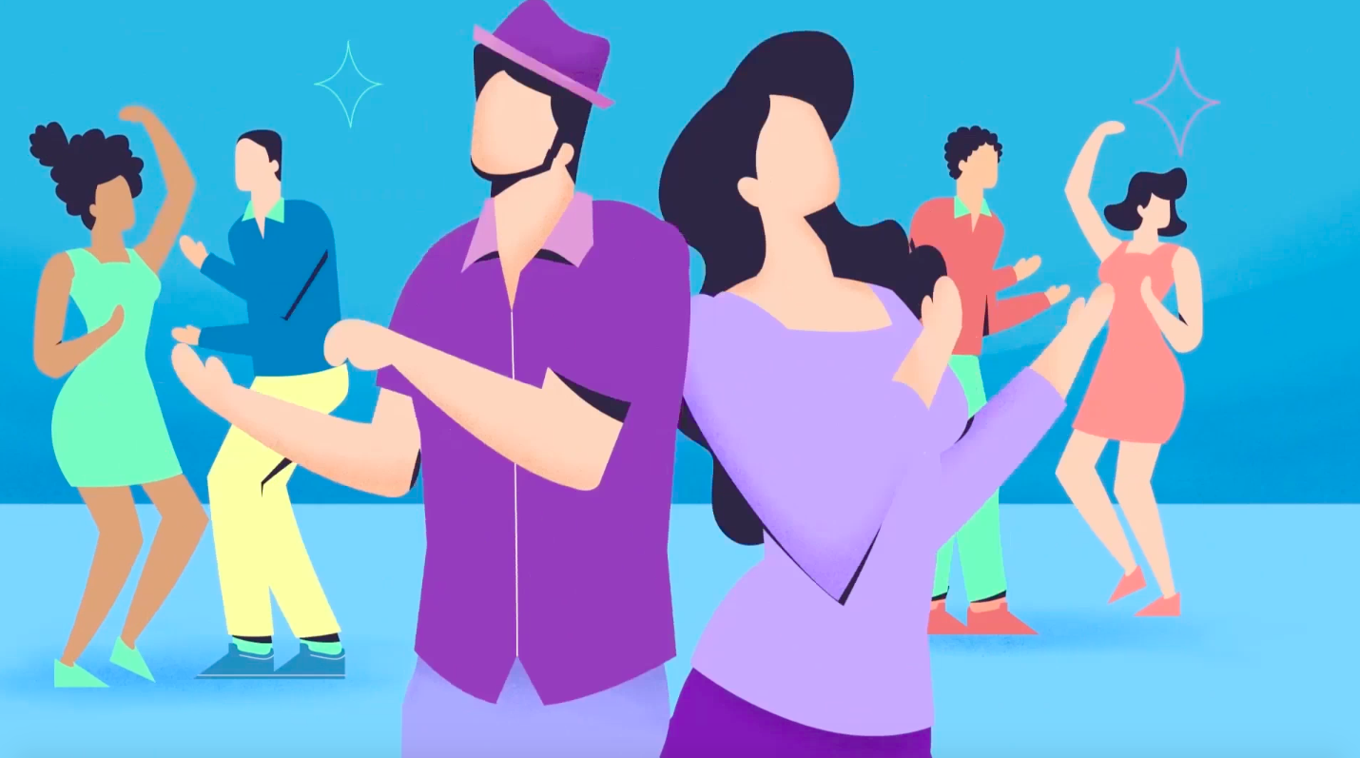  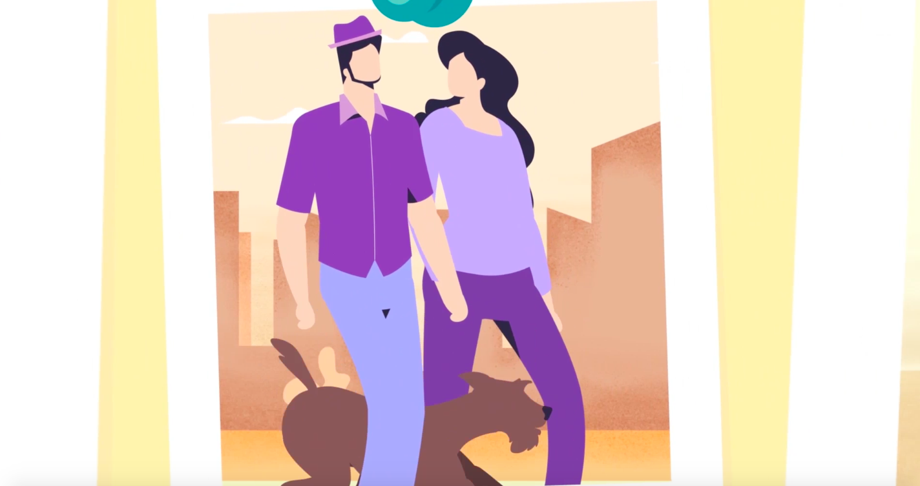  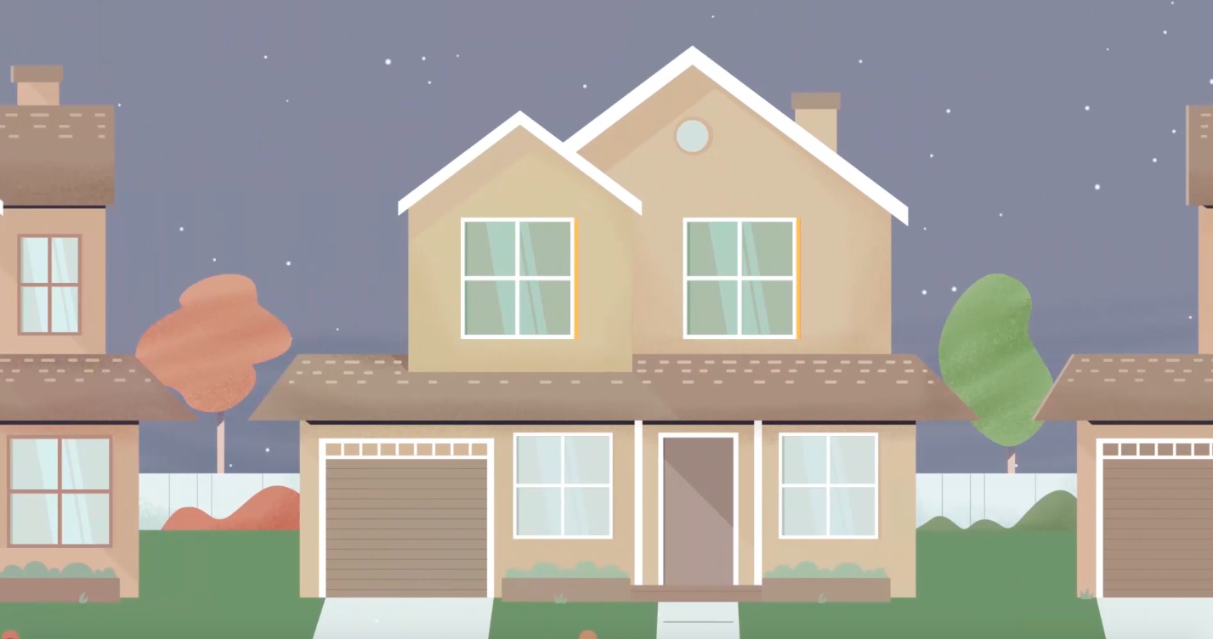
5. You have your first kid. Second kid.  Remember those nights when you could sleep?  6. Your family depends on you, and you worry, about what will happen, if one day, you were no longer there.  We can all relate. |   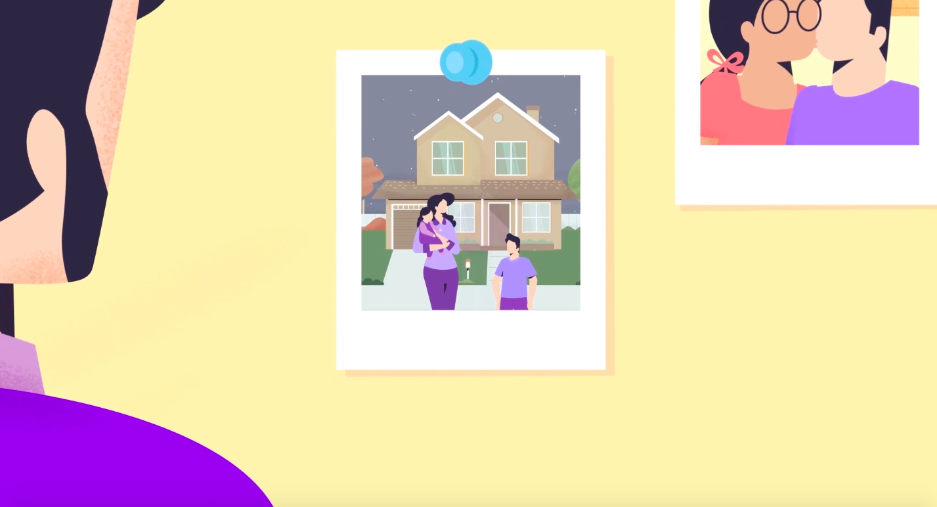
7. The good news is that now, you, and millions of others like you, no longer have to worry because Lifefy is “Creating the Path to Peace of Mind”, by protecting what matters most to you. | 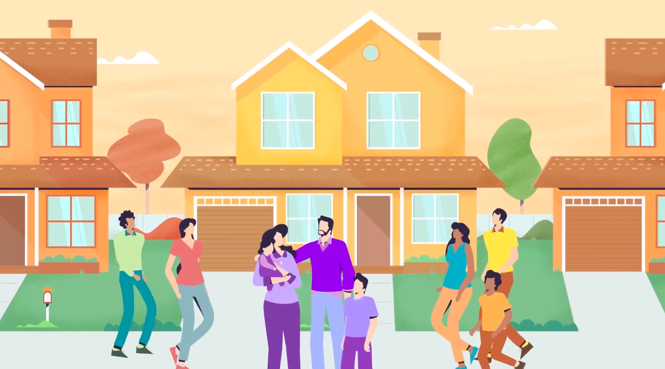  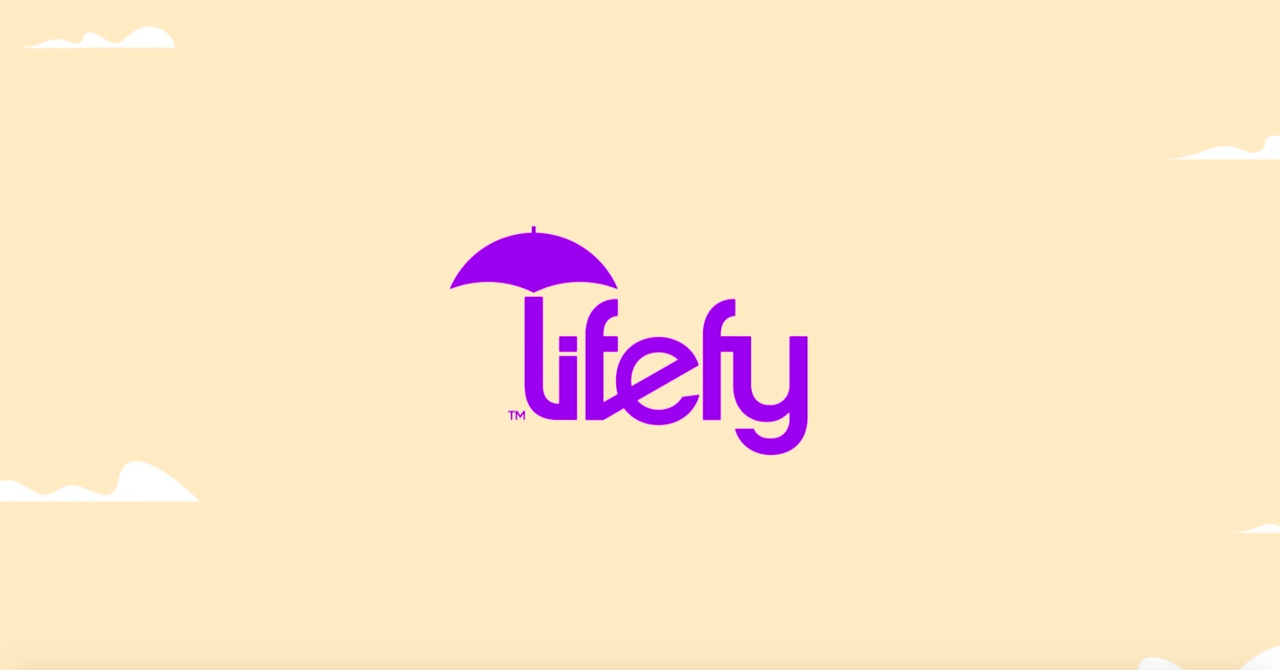
8. Get covered instantly using your mobile device, without medical exams, hours on the phone or weeks waiting for an answer.  9. We'll help you figure out the exact coverage you need at a price you can afford, and you can easily change your coverage as life happens. | GFX: FAST  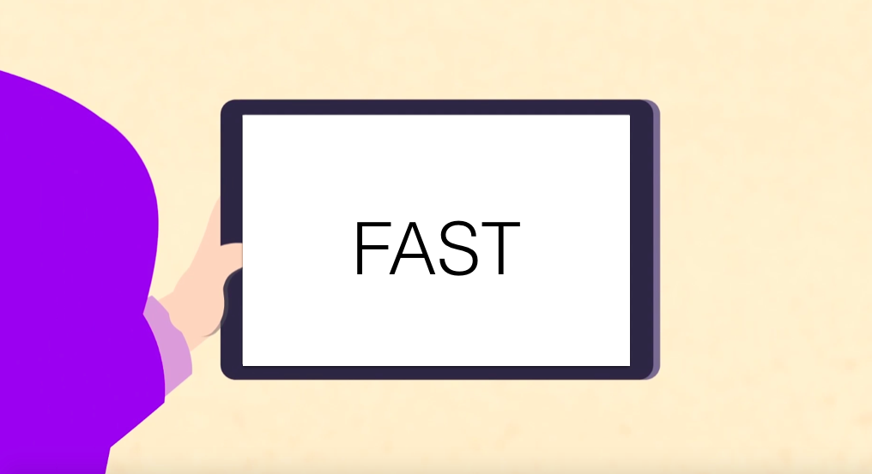  A BUTTON WITH THE WORDS “PURCHASE POLICY” COMES UP AFTER “EASY” A HAND CLICKS ON IT  GFX: EASY  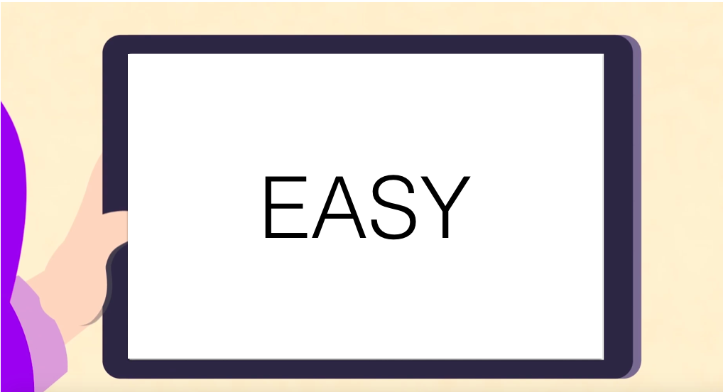  THREE DOLLAR SIGNS COME UP, HAND CLICKS ON SCREEN AND ONE OF THEM DROPS OFF  GFX: AFFORDABLE  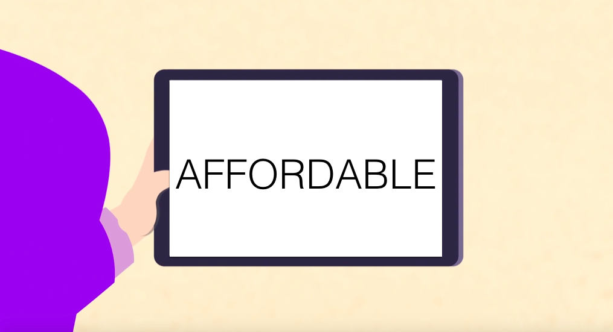
9. We'll help you figure out the exact coverage you need at a price you can afford, and you can easily change your coverage as life happens.  It's as simple as that.  [logo]  Lifefy  Creating the Path to Peace of Mind | **Include only two kids.  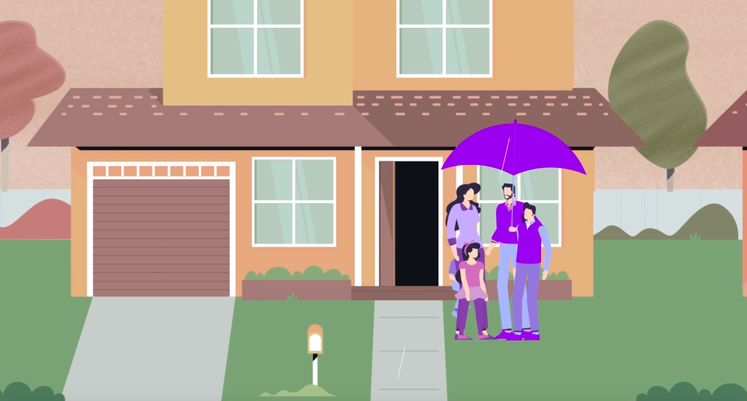  ENDING: Maybe the family walks towards the horizon and as they walk and disappear the umbrella becomes the logo.

